Circle of Doom?

Social Media and the Amplification of Negative News

A. Trevor Thrall*, Andrew Armstrong, Talha Öz

George Mason University

Prepared for Presentation at APSA Annual Meeting

San Francisco, USA August 2014

*Corresponding author: [athrall@gmu.edu](mailto:athrall@gmu.edu)

Our digitally networked world fuels the dream of the democratization of

thought, ideas and flows of information.

— John Wihbey, 2014

[S]ome news organizations are tailoring their online content on social media to get maximum click-throughs by playing to readers’ prejudices and promoting emotive reporting. Viewing numbers drive revenues across the media, and this true of the internet too. It is a good commercial strategy.

—Oliver Wright 2014

One of the most common observations about American political news is that it is negative (Berkowitz 1991; Lichter and Noyes 1996; Shoemaker 1996). Popular consensus—and considerable research— also suggest that the news has is becoming increasingly negative (Sabato 1991, Patterson 1996; Altheide 1997). Patterson (1996) found that, since 1960, coverage of bad news has increased threefold, becoming the "dominant tone of news coverage of national politics (see also Lichter & Amundson 1994). Even worse, most commentators agree that negative news has poisonous and disruptive consequences for public attitudes, elections, the policy process, and the conduct of politics more generally (Patterson 1996; Ansolabhere and Iyengar 1992; Sabato 1991; Lichter & Amundson 1994; Soraka 2006; Trussler & Soraka 2014).

Historically, there has been a strong tendency for citizens to blame journalists and news organizations for the negative tone of a great deal of the news (Hermida 2014; Altheide, 1997; Pew Study 20XX). Despite the public’s proclaimed distaste for negative news, however, many scholars (not to mention journalists) have pointed out that news organizations are simply trying to give the public what it actually is willing to consume (Graber 2010). And as a good deal of research has noted, most citizens display little interest in most political news and when confronted with a choice usually choose to consume other forms of information and entertainment (Prior XXXX; Baum XXXX). Even more fundamentally, a considerable body of research on negativity bias in personal cognition (Kahneman & Tversky 1973; Rozin et al. 2001) and communication (Heath 1996; Soroka 2006) suggests people are hard-wired to attend more closely to negative news and information.

The role of the public’s negativity bias matters more now than ever before, thanks to social media like Facebook and Twitter. In the past, news organizations determined the balance of topics and issue frames that reached the public, along with the overall tone of the news. Today, however, by reposting, forwarding, sharing, retweeting, and other mechanisms now available on social media, citizens have the ability to alter news flows based on their own interests. By amplifying favored stories and sidelining others, the public has become an active participant in the news cycle. When public selectivity is compounded across hundreds of millions of users, the net result can be a profound shift in the content and tenor of the public sphere.

The new potential of the public’s negativity bias is poignantly illustrated by the Fukushima nuclear disaster. In the aftermath of the tsunamis and subsequent meltdown, the Japanese authorities quickly turned to Twitter to disseminate information domestically and internationally (Wallop 2015; Li et al 2014). This no doubt seemed like a reasonable strategy; after all, social media is the perfect medium to quickly spread information to those affected.

With the benefit of hindsight, however, the evidence suggests that social media had the *opposite* of the desired effect. Instead of amplifying official messages—sharing alarming and reassuring messages in corresponding proportion—lingering public fear led to retweeting that was heavily skewed towards alarmism. At the most extreme point, retweets were over a third more likely to express concern and danger compared to the average government tweet from the corresponding period (Li et al 2014). Thus, rather than enhance the government’s outreach, the "the voice of the government was either drowned out or ignored by the Twitter community" (Li et al 2014, 84). The preponderance of negative information may even have undermined public trust in the government. This lack of trust, in turn, may have made the public less likely to retweet reassuring messages in the future. Following Kasperson et al’s (1988) arguments of the social amplification of risk, we argue in cases like Fukushima the social media degrade the quality of public information by edging out balancing information and perpetuating alarmism.

Fukushima provides a dramatic example of a dynamic that now takes place invisibly on a global scale. Every day citizens encounter news about politics and about the world on social media, some of it positive, some of it negative, and then decide whether or not to share that news with others. The critical question is thus: do people illustrate a systematic negativity bias with respect to the news they share on their social networks on a daily basis?

If so, one can imagine a self-reinforcing circle of doom emerging. In phase one, a news organization publishes a series of news stories. In phase two, the news organization must decide which of those stories to highlight by tweeting about them. In phase three, the people who follow those news organizations on Twitter encounter those tweeted news stories and decide whether to retweet them or not. If the public displays a negativity bias, then they would amplify the negative tone of the overall information environment by increasing the ratio of negative to positive news tweets available for consumption. However, given the ease with which news organizations can track the performance of their tweets, we can also imagine that public patterns of retweeting will influence which stories news organizations decide to tweet about in the first place in order to maximize their virality. And logically, then, if a news organization understands that negative stories are being retweeted most often, it then has a clear incentive to produce more negative stories in the first place – the circle of doom.

Given the rapid rise of social media and the massive shift in news consumption habits the digital era has spawned, the answer to this question has serious implications. Facebook now has more than a billion users, Twitter a quarter-billion. In 2013 the analytics website Chartbeat reported that 26% of measured traffic to news websites originated from social sources.[1]  A Reuters Institute (2013) report suggests nearly 40% percent of those under 45 in the US turn to social media for news, with the youngest Americans even more likely to do so (Pew 2014). Even more pointedly, as Wu et al (20XX) found, the majority of news tweets that people encounter on Twitter are the result of someone else retweeting that news in the first place, making public decisions about retweeting news central to our understanding of news flows through the Internet. Over time, as the Internet evolves, the line between old and new media will only blur further and the potential for the public to shape the overall information environment will grow.

To investigate the power of the public to reshape the news flow we conduct a series of content analyses of published news, tweeted news, and retweeted news from eight mainstream news organizations including ABC News, the Associated Press, CBS News, CNN, Fox News, NBC News, the New York Times, and the Washington Post, comparing the average positive/negative tone of each in an effort to determine whether the public displays a negativity bias in its news retweeting behavior and whether news organizations in fact tweet more negative news than they publish in the first place.

In the end our results cut against both our initial expectations and the conventional wisdom. We find that although news organizations tweet very slightly more negative news than they initially publish, the public does not display an obvious negativity bias in its retweeting of news. Further, the public’s retweeting behavior is so insensitive to negativity levels that we believe our results call in to question many assumptions about the relationship of the public to the news media and the role of social media in shaping news consumption and information flows in the digital age.

Our exploration is divided into four sections. First, we review the literature on negativity bias and outline our hypotheses with regard to news flow on Twitter. We then describe our dataset and methods before providing our results. We end by reflecting on the broader implications of the public’s growing influence on the public sphere.

**Negativity Bias: Is the Public Sphere Doomed from the Start?**

Psychologists tell us that human brains are hard-wired with a powerful negativity bias. Our ancestors faced a host of potential threats, any number of which might be lethal. Will this strange new critter cuddle/kill me? Will this new plant satiate/poison me? Many have argued that the evolutionary payoffs for negative/positivity biases are profoundly asymmetrical (Siegrist & Cvetkovich 2001; Rozin & Royzman 2001). Given our past is understandably riskier to embrace positivity, the logic goes, than to default to negativity and suspicion. Moving from historical caves to contemporary cubicles, human proclivity towards negativity is a mainstay of contemporary scholarship. Improvisations on the common theme have been suggested in nearly all stages of human cognition. Negativity bias, studies suggest, plays a central role mediating how information is received, processed, and ultimately shared.

There is considerable evidence for an asymmetric relationship between positive and negative stimuli of comparable magnitude; the former has been consistently shown to have a greater impact on evaluation and opinion formation (Kanouse & Hansen 1971; Peeters & Czapinski 1990). The central role of negative information lies at the heart of prospect theory (Khanenan & Tversky 1979; Tversky & Khaneman 1991). The concept of *loss aversion*—where individuals are more sensitive to a potential loss than a comparable gain—underscores the fact that negativity and the threat hold a privileged place in human cognition. This inclination is reflected on how information is processed on political (Sabato 1991; Huddy et al. 2005), economic (Soraka 2006), scientific (Li et al. 2014) and social (Sigrist & Cvetkovick 2001; Altheide & Michalowski 1999) issues.

Prioritizing negativity may also have perfectly rational justifications. A number of scholars emphasize the importance of a cognitive "reference point" in the context of information (Fiske 1980; Skowronski & Carleson 1989; see also Trussler and Soraka 2014). If humans are generally upbeat, as some psychological studies suggest, then negative information is further from baseline optimism than positive information. It is therefore novel and, by extension, potentially more interesting. Holding with this, Trussler & Soraka (2014, 4) suggest that the: "[P]otential usefulness of deviant/negative information that makes it particularly attention-grabbing is echoed in work on why consumers have rational incentives to focus on negative and/or strategic news frames." In effect, if negative news is more valuable, one would expect people to make special efforts to acquire negative information. Indeed, in an experimental study simulating news-seeking behavior, Trussler & Soraka found that participants were more likely to choose negative stories than neutral or positive alternatives

The second manifestation of individual-level negativity bias is more directly related to the current study: sharing. In short, does internal sensitivity to negativity influence what is selectively passed on to others? In next section we discuss the extent to which media outlets choose to emphasize negative information. For now, consider how story attributes may influence sharing within one's life, either in person or via social media.

Here, the record is mixed. There is some evidence that sad (Berger 2012; Berger & Milkman 2012) or depressing (Newman 2011) stories are less likely to be shared than coverage than is positive or upbeat (see also Hermida 2014). This is possibly because that individuals are reluctant to pass on stories that might make recipients feel poorly or fearful (Peters et al. 2009). In contrast, other studies suggest that negative or "deviant" (Diakopolous & Zubiaga 2014) news items are in fact *more* likely to be shared between individuals. What is one to make of this? Is it simply that disseminating negativity is context-dependent, or is there something else at play?

It is possible that the intensity, not simply the valence, of information contributes to sharing behavior. Heath (1996) distinguished between two dimensions of news coverage, valence (whether the news is good/bad) and extremity (how good/bad is the coverage). Through a series of observational surveys he assessed whether intervals were more/less likely to share news stories based on these dimensions. At first blush his findings do not seem to support the negativity hypothesis. Across cases individuals were more likely to share central stories (i.e., not particularly good/bad) with their friends over more extreme alternatives. He submits this may be due to the fact that moderate stories are perceived as more credible, and therefore more worth sharing. The analysis, however, does not end there. Digging deeper, Heath found that when extreme news stories *were* shared, participants were more likely to pass along bad news than ostensibly "equally believable" good news (91). This is consonant with the earlier reference-point hypothesis that negative news is father removed from our cognitive baseline, and therefore more novel/interesting (Fiske 1980; Skowronski & Carleson 1989).

Muddling the picture a bit further, surveys of the public news consumption habits and their feelings about the news illicit confounding narratives. One the one hand, studies routinely show that news about war, disasters of all sorts, and crime rank among the most-followed. And yet on the other hand, surveys also reveal clear public distaste for media negativity, with many going so far as to say that they don’t read or watch the news about politics as a result (Pew 2002; Gibbons 2003; INMA 2003; RTNDA 1996). A 2004 Pew study, for example, found that 45% of Americans agreed that watching and reading news depressed them. Further, the public’s views of the media and its performance have grown increasingly grim since the 1980s, with a large majority now believing that the media are biased, inaccurate, and a plurality assessing the media’s overall impact on American democracy as negative (Pew 2011). Thus, although psychologists and journalists may agree on the human bias toward negativity, it is less clear that the public appreciates negativity in their news.

*Hypotheses*

The circle of doom might thus begin, we suggest, with mainstream news organizations publishing content. Surveying the day’s headlines, executives then select a subset of the most important/interesting stories to promote through social media. As noted above, considerable evidence suggests that negativity is an important criterion for “newsworthiness” from an agency’s perspective and, by extension, this should influence what stories get highlighted through Twitter (Baum & Groeling 2010; Graber 2010). This leads to our first hypothesis:

*H1. "Tweeted news"—stories which news organizations promote with a tweet will be more negative on average than the "published news" in a given timeframe.*

The public now has a sample of tweets and (in the vast majority of news tweets) links to the corresponding published content. Readers now decide whether or not to retweet a story that comes their way. As noted above, a great deal of psychological literature has established that humans have a hard-wired emphasis on negative information, and news consumption data suggests that the most followed news topics do indeed include war, disaster, and crime. Thus, our second hypothesis:

*H2. The content of retweeted news will be more negative than the overall sample of tweeted news.*

At this point one might reasonably ask: Why should negativity be as important in sports or entertainment news, for example, as in weather, scandal, or political news? In a study analyzing email forwarding of online news stories, for example, Bockowski & Mitchelstein (2013) noted that sharing behavior differed by story topic, with important differences between hard and soft news topics. We concur and considerable it reasonable to imagine that the relevance of negativity to a story—and, by extension, whether it is a meaningful criterion for sharing—is contingent on the nature of the content in question.

Negativity in culture or fashion news may make for a good story, but might not carry weighty real-world consequences. In contrast, negativity in political or economic news is likely to have tangible consequences. Negativity in “hard” news may, in fact, make a story more “newsworthy.” Thus hypothesis three:

*H3. The public’s negativity bias will be more pronounced for hard news than for soft news topics, which might in fact illustrate the opposite – a positivity bias.*

Taken together, the hypotheses articulate a circle of doom model in which negative news is amplified as it travels through social media. Figure 1, below, offers a simplified representation of what this might look like. The baseline (curve A) is the distribution of tone in all *published* news from mainstream outlets. From this, news outlets select a subset of stories to promote with a *tweet*, the distribution of whose overall tone is represented by curve B. Finally, the public then decides which of those tweeted news stories to retweet, leading to a new distribution of tone within the information environment, represented by curve C. The core expectation, in short, is that news as it moves from published news (rightmost curve) to the public (the leftmost curve) becomes increasingly negative in aggregate tone.

**Figure 1 About Here: Dueling Bell Curves of Negativity**

**Data and Methods**

We began by harvesting the most recent 3200 tweets from eight mainstream news outlets that all have a large following on Twitter.[2] As Table One shows, some news organizations tweet far more frequently than others. As a result, the time periods under study vary from just nine days for the New York Times, which tweeted most frequently, to almost four months in the case of CBS News, which tweeted least frequently.

We then used a web-scraping program to visit the URLs embedded in every tweet and download the corresponding news story, giving us our database of “tweeted news.” Thanks to Twitter’s focus on tracking user behavior, the downloaded information also included how many times each news tweet/story had been retweeted. And thanks to the manner in which the news organizations tagged their news stories, we were also able to identify the general topic area of each news story in order to ascertain whether topic area mediates negativity bias. The name and number of categories varied by organization (there were over 80 across our eight targeted publishers) but all of the sources contained a common core of major categories (i.e., world, sports, Middle East, etc). As a first-look at the mediating role of topic area on the impact of the negativity bias we selected three common tags: one “hard” news category (politics), one ambiguous category (world), and one “soft” topic (sports).

Finally, to build our database of published news we used Lexis-Nexis to collect all the published news for each organization over the same time period, which resulted in anywhere between 328 news stories (Fox News – malfunction; we’re working on getting the real number!) and 14,456 news stories (Washington Post).

**Table one about here**

*Sentiment Analysis*

With the news stories in hand, we then used *TextBlob*,[3] an open-source package for Python, to conduct unsupervised sentiment analysis on A) the corpus of originally published news by each organization, and B) the corpus of news stories actually tweeted by each news organization. Then, combining the sentiment scores for each tweeted news story with the retweet information allowed us to calculate the overall sentiment distribution for C) retweeted news. Finally, we repeated this exercise for tweeted news and retweeted news looking at three specific topic areas of news: politics, world, and sports.

Automated content analysis has become a widely used tool in political science, allowing for a “systematic analysis of large-scale text collections” (Grimmer & Stewart 2013, 268). Employing a widely validated sentiment dictionary Text Blob scans each document for keywords, each of which is associated with a positive or negative tone. Once it has identified all the keywords in a document the program creates a net document score ranging from -1 (wholly negative) to 1 (wholly positive). While this method is certainly cruder than manual coding, many studies have validated the reliability of unsupervised sentiment analysis and it has several key advantages, most importantly that it avoids human error and enables the analysis of vastly larger quantities of data than would be feasible manually (Soroka, various, e.g., as well as XXXX).

**Results**

Table Two presents the heart of our analysis in summary form. Regarding Hypothesis 1, we found that in 7 out of 8 cases, the tone of tweeted news was slightly more negative than the tone of the originally published news, with only the Washington Post tending to tweet in a more positive direction. Though given the large sample sizes involved these figures are statistically significant (sorry, official stats still in progress!), these differences are in reality very small. For the ABC News, for example, sentiment of published news averaged 0.121. This is equivalent to 56% completely positive stories and 44% completely negative stories. Sentiment of ABC News tweeted news, on the other hand, averaged a positive 0.073, which is the equivalent of 53.5% completely positive news stories and 46.5% completely negative stories.

Regarding Hypothesis 2 we find no support for a public negativity bias. In five cases the tone of retweeted news was more positive than the tweeted news, and in all eight cases the difference in mean sentiment was extremely small whatever the direction. Figures Two and Three present the data from Table Two in visual form and make clear that public retweeting neither significantly amplified nor significantly dampened the negativity of the news flow.

Finally, Table 3 and Figure 4 indicate very modest support for Hypothesis 3, illustrating that of the three topics retweets of both the World and Sports news tweets were more positive while the tone of retweets of political news was slightly more negative than the originally tweeted news. Again, however, the differences are slight enough to cast significant doubt on the circle of doom dynamic at the topic level.

**Table 3 About Here: Sentiment Polarity by Subject**

**Figure 4 About Here: Sentiment Polarity of Political News by Source**

**Discussion**

The preceding figures merit a moment’s pause and reflection. Not because they are dramatic; but because they are spectacularly *unexceptional*. Each curve appears, more or less, *identical.* At first blush, neither H1 nor H2 appear supported, since there does not appear to be meaningful amplification of sentiment across the news cycle. There is no top-line evidence that news organizations or the public use Twitter to systematically favor negative over positive news.

This calls into the question the entire concept of a circle of doom in the news. While social media may increase the breath of coverage, it does not appear to have any influence on tone*.* This is surprising given the substantial literature indicating the existence of negativity bias for both individuals and news organizations. Nor, recalling the research following Fukushima, do the findings support earlier studies specifically focused amplification through social media. Even if negativity bias was not supported, existing literature could have been marshaled to make a case for positive or extreme news bias. The fact that these alternative outcomes were similarly unsubstantiated is noteworthy.

This non-result is, perhaps, the most curious of all possible outcomes. Based on this first cut of the data the public appears a perfect—*but wholly passive*—mirror of the news they receive. Is it really the case that the public passively pays-forward the content they receive, or is there something happening beneath the surface?

There is very tentative evidence that readers have a modest negative bias in hard news relative to softer issues. Retweets for the one unequivocally hard topic—political news—was indeed slightly more negative than the tweeted news. The two softer topics actually exhibited *positive* sentiment amplification. However, as mentioned, these are only three topics of scores. Future analysis of a broader base of topics will help assess if there are consistent trends in public amplification across hard/soft news.

Additional delving into the data will help determine if, when, and to what extent social media amplifies the tone of news coverage. Before ending, it is worth taking a few moments to broadly reflect on the social implications of negativity in the news. Despite the fact that negativity bias in individual cognition is natural, and possibly beneficial, it's presence among the media is often portrayed as deplorable. Journalists may leverage negativity to help keep power "accountable" (Carlyle et al. 1976; Soraka 2006). Too little criticism whitewash legitimate threats, the risk of glossing over dangers and abuses of power (Hage et al. 1976; Soraka 2006). Particularly in the post-Vietnam/Watergate era, journalists may feel pressured to be "vocal cynics" rather than "silent skeptics" of politics and society (Patterson 1993, 73-4). Going negative is never pretty, the story goes, but it may be necessary for the health of a well-functioning society.

The counterpoint is that less altruistic motives inflate negativity in news coverage. The experimental observations that individual seek out negative stories has significant implications for the real-world news cycle. Clicking a news-link is, in effect, "voting" for that story (Hermida 2014). Companies are able to gauge an issue's resonance through site traffic. The media, cynics suggest, exploit our innate negativity bias as a strategy to drive public interest, and ultimately sell copy/clicks.

Pursuing negativity primarily as a marketing gimmick undermines the value of the media as social watchdogs (Sabato 1991. The well-worn adage "garbage-in, garbage out" is all-too-revenant to the discussion of free media. Flooding the information environment with doom and gloom may lead to skewed opinion and public policy. At its best, negativity may be viewed as an lamentable, but largely benign, consequence "infotainment" era. At worst, too much negativity may descend into the realm of "yellow journalism," delightfully decried as a "shrieking, gaudy, sensation-loving devil-may-care" approach to reporting (Emery 1977; cited in Patterson 2013, 7).

Ultimately, there is a grey line between going negative as a check on power versus its pursuit as a marketing tactic. To paraphrase Goldilocks, what level of negativity is *just* right? This normative question, while important, is ultimately tangential to the issue at-hand. In terms of the present discussion, we are interested in assessing if/how/when the introduction of social media into the news making cycle influences mainstream coverage.

Scholars have suggested that the rise of social media compliments the democratic process both in the US (Loader & Mercea 2012) and abroad, exemplified by the Arab Spring (Lotan et al. 2011; Howard & Hussain 2013). Philosophically social media resonates with the norms of participatory democracy. Providing a broad digital platform makes it easier for average citizens, not political or media elites, to engage with current events. Discussing the democratization of news and information, Wihbey (2014, 3) boldly claims:

“More than any prior technology, social media have the possibility of driving this democratization of information even further, undercutting the agenda-setting of large media outlets and their relative control of news and information flows.”

Social media is clearly powerful and pervasive, but what does it ultimately mean for the nature of the information in the public sphere? We counter that not everything is rosy on the digital frontier. While social media may be a sword of democracy, it is double-edged. Broadening awareness of abuses of power and timely debates... probably good for society. Playing into to public fascination with fear, negativity, and sensationalism... not so much.

As with the opening parable of Fukushima, flooding the information environment with doom and gloom may lead to skewed opinion and public policy. The problem is even more pernicious when you consider that social media may not simply drown out other perspectives, it can even influence messages before they are shared!

Many have argued that social media "undercuts" traditional news outlets (Wihbey 2014). While this may be the case in some instances—particularly when freedom of the press is limited—this is far from universal. We suggest that rather, than be undermined by social media, savvy networks have made a virtue of necessity co-opting social networks to compliment rather than compete with their coverage.

**References**

Altheide, D.L. (1997). The news media: the problem frame and the production of fear. *The Sociological Quarterly*, 38(4), 647-668.

Altheide, D.L, & Michalowski, R.S. (1999). Fear in the news: a discourse of control, *The Sociological Quarterly, 40(3),* 475-503.

Baum, G. Groeling, M. (2010). *War stories: The causes and consequences of public views of war*. Princeton, NJ: Princeton University Press.

Berger, J. (2012). Crafting contagious, *Google Think Insights*. https://www.thinkwithgoogle.com/articles/crafting-contagious.html

Berger, J., & Milkman, K.L. (2012). What makes online content viral?, *Journal of Marketing Research,* *49(2)*, 192-205.

Boczkowski, P.J. & E. Mitchelstein (2013). *The news gap: When the information preferences of the media and the public diverge*. Cambridge, MA: MIT Press.

Diakapoulos, N. & Zubiaga, A. (2014). Newsworthiness and network gatekeeping on twitter: the role of social deviance. *Proceedings of the Eighth International AAAI Conference on Weblogs and Social Media*

Emery, E. (1977). *The press and america: An interpaerative history of the mass media*, Englewood Cliffs, NJ: Prentice-Hall.

Fiske, S.T. (1980). Attention and weight in personal perception, the impact of negative and extreme behavior. *Journal of Personality and Social Psychology¸38*, 889-906.

Graber, D. (2010). *Mass media and american politics*. Washington, DC. CQ Press.

Grimmer, J. & Stewart, B.M. (2013). Text as data: The promise and pitfalls of automatic content analysis methods for political texts. *Political Analysis*, 21(3), 267-297.

Hage, G.S, Dennis, E.E., Ismach, A.H & Hartgen, S. (1976). *New Strategies for Public Affairs Reporting*. Englewood Cliffs NJ: Prentice-Hall.

Hansen, L.K., Arvidsson, A, Nielson, F.A., Colleoni, E. & Etter, M. (2011). Good friends, bad news – affect and virality on twitter. Submitted to The 2011 International Workshop on Social Computing, Network, and Services

Heath, C. (1996). Do people prefer to pass along good or bad news? Valence and relevance of news as predictions of transmission propensity, *Organizational Behavior and Human Decision Processes, 68:2*, 79-94

Hermida, A. (2014). *Tell everyone: Why we share and why it matters*. Canada: Doubleday.

Howard, P.N. & Hussain, M.M. (2013). *Democracy's fourth wave? Digital media and the arab spring*. New York, NY. Oxford University Press.

Huddy, L., Feldman, S. Taber, C. & Lahav, G. (2005). Threat, anxiety, and support of antiterrorism policies, *American Journal of Political Science*, 49(3): 593-608.

Kahneman, D. & Tversky, A. (1979). Prospect theory: an analysis of decision under risk. *Econometrica,* 47(2), 263-292

Kanouse, D. & Hansel, L.R. (1971). Negativty in evaluations. In E.E. Jones, D.E. Kanouse, H.H. Kelly, R.E. Nisbett, S. Valin & B. Weiner (Eds.) *Attribution: Perceiving the causes of behavior* (pp. 47-62). Morristown, N.J.: General Learning Press

Katz, E. (1957). The two-step flow of communication: An up-to-date report on a hypothesis. *Public Opinion Quarterly,* 21(1), 61-78.

Koren, G. & Klein, N. (1991). Bias against negative studies in newspaper reports of medical research. *Journal of the American Medical Association,* 266, 1824-1826.

Li, J., Vishwanath, A., & Rao, H.R. (2014) Retweeting the fukushima nuclear radiation disaster, *Communications of the ACM, 57(1),* 78-85

Lichter, R.S, & Amundson, D. (1994). Less News is Worse News: Television News

Loader, B.D, & Mercea (2012). *Social media and democracy: Innovations in participatory politics*. New York, NY: Routledge.

Lotan, G., Graeff, E., Ananny, M., Gaffney, D. Pearce, I. & Boyd, D. (2011). The revolusions were tweeted: Information flows during the 2011 tunisian and egyptian revolutions, *International Journal of Communication, 5*, 1375-1405.

Rozin, P. & Royzman, E.B. (2001). Negativity bias, negative dominance, and cognition, *Personaitly and Social Psychology*, *5:4¸* 296-320.

Martin, I. & Levy, A.B. (1978). *The pollyanna principle. Selectivity in language, memory, and thought*, Cambridge, MA: Schenkman.

Trussler, M. & Soraka, S. (2014). Consumer demand for cynaical and negative news frames, *The International Journal of Press/Politics*, 1-20.

Sabato, L. (1991) *Feeding frenzy: how attack journalism has transformed american politics.* New York, NY: The Free Press.

Siegrist, M. & Cvetkovich, G. (2001). Better negative than positive? evidence of a bias for negative information about possible heath dangers, *Risk Analysis, 21:1,* 199-205.

Soraka, S.N. (2006). Good news and bad news: asymmetric responses to economic information. *The Journal of Politics¸ 68:2*, 372-385.

Skowronski, J.J & Carleson, D.E. (1989). Negativity and extremity bias in impression formation: a rewview of explanations, *Psychology bulletin, 105(1)*, 131-142.

Patterson, T.E. (2013). *Informing the news: the need for knowledge-based journalism*. New York, NJ: Vintage Books.

Peters, K., Kashima, Y. & Clark, A. (2009). Talking about others: emotionality and the dissemination of social information. *European Journal of Social Psychology¸* *39(2),* 207-222.

Newman, N. (2011). *Mainstream media and the distribution of news in the age of social discovery*. Oxford: Reuters Institute for the Study of Journalism

Patterson, T.E. (1993) *Out of order*. New York: Knopf.

Patterson, T.E. (1996). Bad news, period. *Political Science and Politics*, 29, 17-20.

Coverage of Congress. In *Congress, the Press and the Public*, eds. Thomase E. Mann   
and Norman Ornstein. Washington: American Enterprise Institute and Brookings Institution

Petters, G. & Czapinsli, J. (1990). Positive-negative asymetry in evaluaions: THe distinction between affective and informational negativity effects. IN W. Strobe & M. Hewstone (Eds.), *Eurpoean review of social psychology*, *61*, 380-391.

Schwartz, J. (2014). Understanding your traffic sources, part 3: social traffic http://blog.chartbeat.com/2013/10/28/understanding-traffic-sources-part-3-social-traffic/. Last accessed August 2015.

*New York Times*, “Innovation,” internal report, 2014. Available at: http://www.scribd.com/doc/224332847/NYT-Innovation-Report-2014.

Reuters Institute for the Study of Journalism. *Reuters Institute Digital News Report (2013).*https://reutersinstitute.politics.ox.ac.uk/fileadmin/documents/Publications/Working_Pape rs/Digital_News_Report_2013.pdf., Last Accessed August 2015.

Stephens, M. & Edision, N.G. (1982). News media coverage of issues during the accident at three-mile island, *Journalism Quarterly*, *59(2)*, 199-259.

Tversky, A. & Kahneman, D. (1991). Loss aversion in riskless choice. *The Quarterly Journal of Economics, 106(4),* 1039-1061

Wallop, H. (2011) Japan earthquake: how twitter and facebook helped. http://www.telegraph.co.uk/technology/twitter/8379101/Japan-earthquake-how-Twitter-and-Facebook-helped.html. Last accessed August 2015.

Whibey, J. (2014). The challenges of democratizing news and information: examining data on social media, viral patterns, and digital influence. *Shorenstein Center on Media, Politics and Public Policy Discussion Paper Series*, *D-85*.

Wright, O. (2014) Are we being dumbed down by ‘news’ from social media? http://www.independent.co.uk/voices/comment/are-we-being-dumbed-down-by-news -from-social-media-9929623.html. Last accessed August 2015.

Wu, S., Hofman, J.M., Mason, W.A., & Watts, D.J. (2011). Who says what to whom on twitter, *International World Wide Web Conference*, 705-714

**Table 1 Twitter and News Descriptives**

|  |  |  |  |  |
| --- | --- | --- | --- | --- |
| **News Outlet** | **# Twitter followers (millions)** | **Time frame**  **of collection** | **#Published stories in time frame** | **# Tweets in time frame** |
| ABC News | 4.23 | Jan 27 - Apr 4 | 3,165 | 3,200 |
| Associated Press | 5.25 | Feb 24 - Apr 4 | 2,372 | 3,200 |
| CBS News | 3.72 | Apr 11 - June 8 | 1,423 | 3,200 |
| CNN | 17.6 | Feb 1 - Mar 11 | 5,063 | 3,200 |
| Fox News* | 5.25 | Feb 16 - Apr 4 | 328 | 3,200 |
| NBC News | 2.3 | Apr 12 - June 8 | 1,090 | 3,200 |
| New York Times | 17.2 | Feb 25 - Mar 4 | 1,823 | 3,200 |
| Washington Post | 4.8 | Mar 5 - Apr 4 | 14,456 | 3,200 |

*\* Complete data forthcoming*

**Figure 1 Dueling Bell Curves of Negativity**



**Table 2. Sentiment Polarity of Published, Tweeted, and Retweeted News**

*Mean sentiment scores (-1 to +1 scale)*

|  |  |  |  |
| --- | --- | --- | --- |
| **News Outlet** | **Published News** | **Tweeted News** | **Retweeted News** |
| ABC News | .121 | .073 | .086 |
| Associated Press | .056 | .053 | .049 |
| CBS News | .107 | .068 | .065 |
| CNN | .079 | .071 | .074 |
| Fox News | .092 | .061 | .065 |
| NBC News | .134 | .058 | .062 |
| New York Times | .082 | .081 | .082 |
| Washington Post | .077 | .087 | .086 |

**Figure 2: Sentiment Polarity of Published, Tweeted, and Retweeted News**

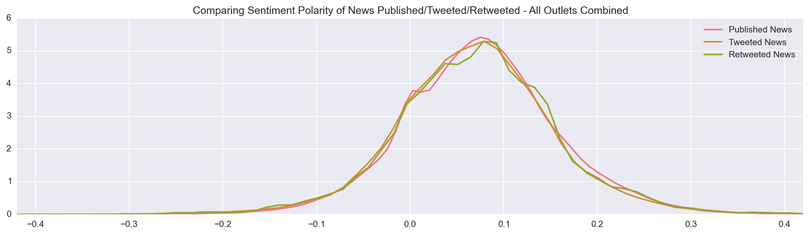

**Figure 3: Sentiment Polarities by Source & Aggregated News**

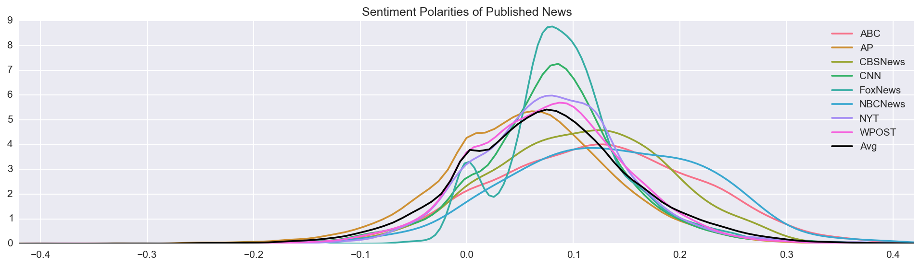

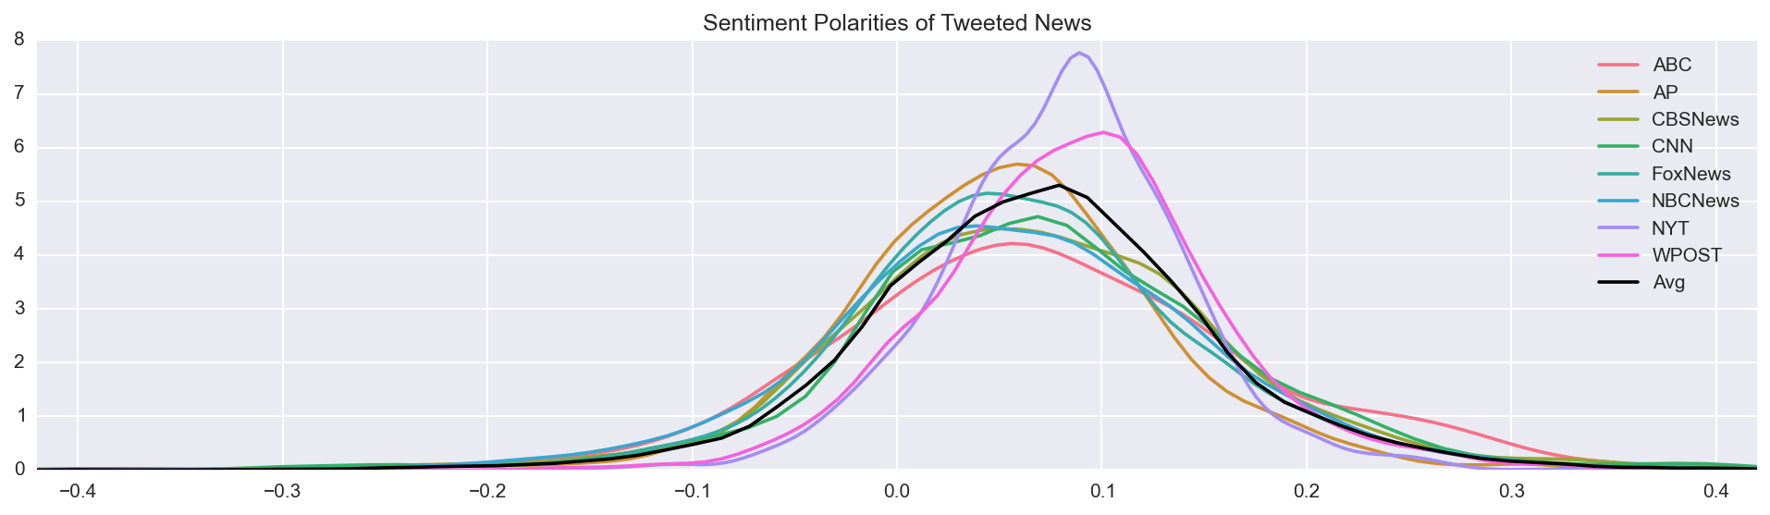

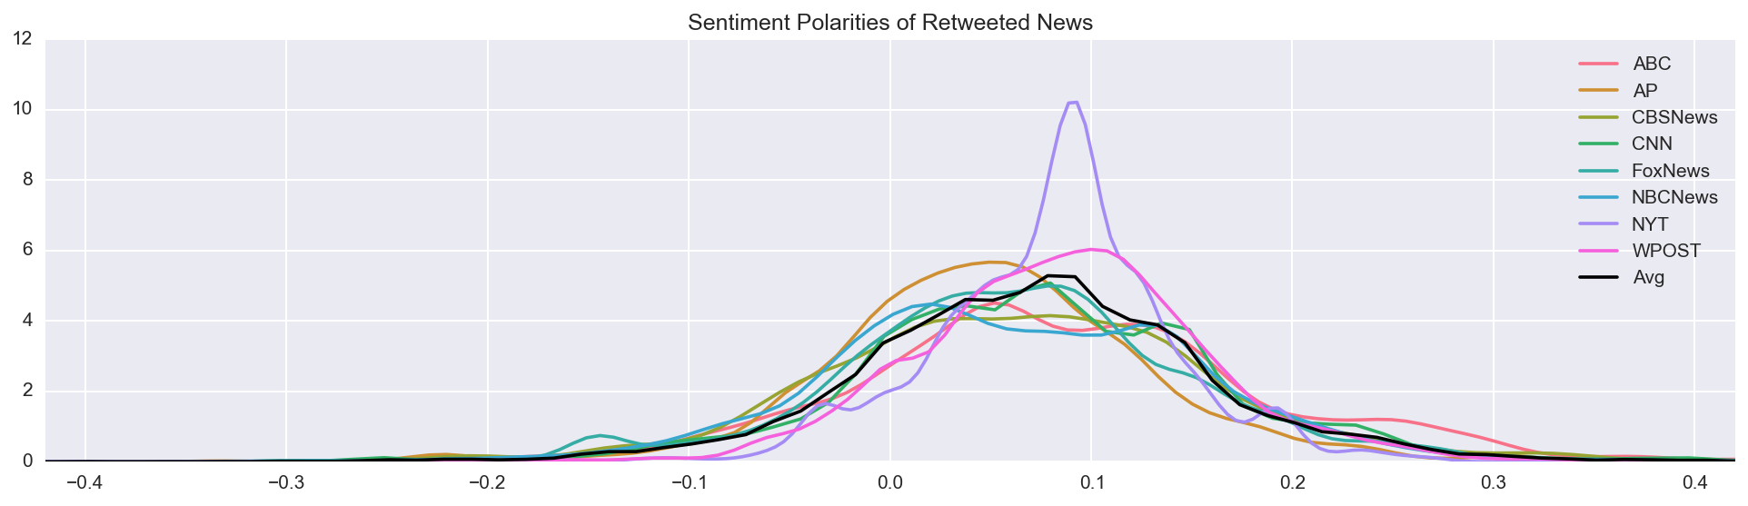

**Table 3: Sentiment Polarity by Subject**

|  |  |  |  |
| --- | --- | --- | --- |
|  | **Tweeted News** | **Retweeted News** | **Polarity Shift** |
| **Politics** | .069 | .067 | -.02 |
| **World** | .042 | .050 | .008 |
| **Sports** | .095 | .111 | .016 |

**Figure 4: Political News Tweet/Retweet Polarity by Source**

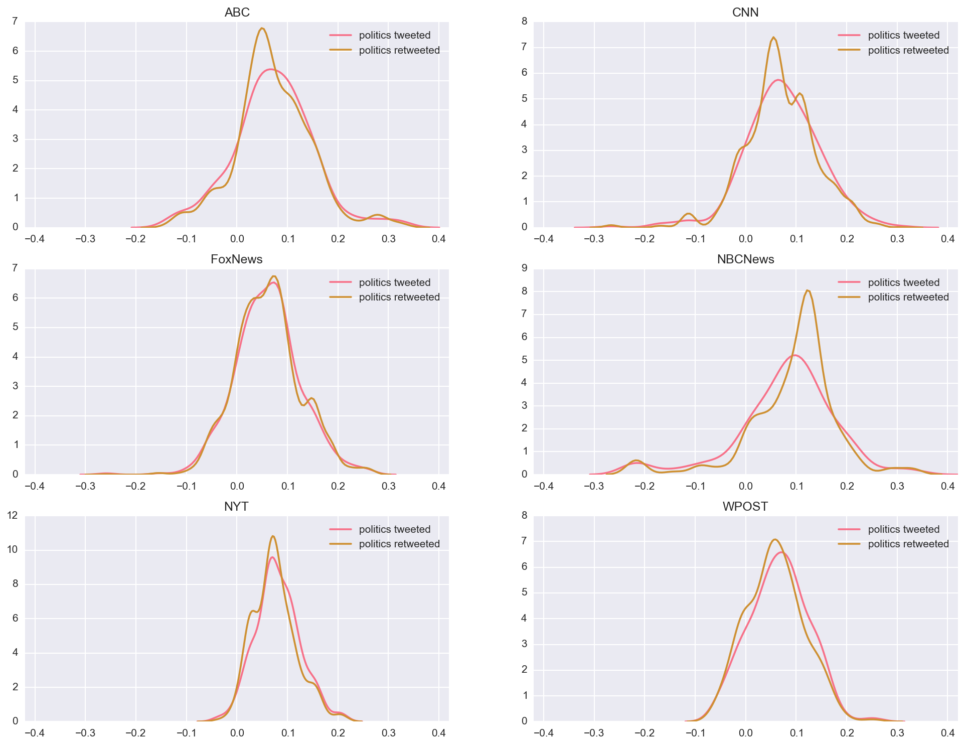

1. It is worth noting that the cited statistics vary widely, both by study and source. In contrast, a 2014 internal memo from the New York Times indicated that less than 10% of its site traffic comes from social media.
2. The number 3200 is dictated by the rules governing use of the Twitter API to download Twitter data.
3. Available at <https://textblob.readthedocs.org>